**Android studio tabbed activity**

Jin Kim

**What is a “tabbed activity”?**

Tapped activity is basically an activity that has different taps.

Important thing is that it happens in one activity and tabs are just fragment.

**Let’s define the sections.**

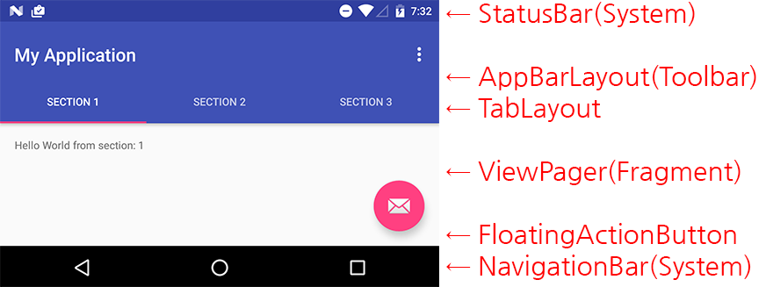

Basic auto generated Swipe ViewPager looks like this.

**Let’s create a project!**

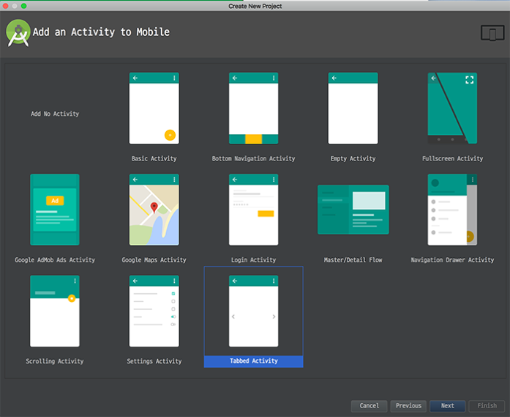

You can find it from very bottom of the list!

There are 3 different navigating style you may choose

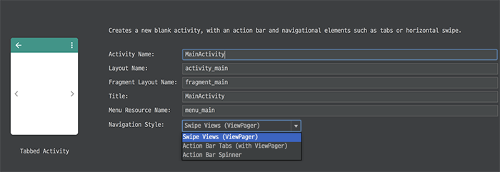

Swipe Views(ViewPager): create view that uses view pager

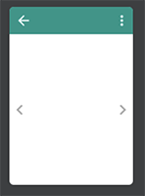

Action Bar Tabs (with ViewPager): Swipe + tab

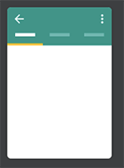

Action Bar Spinner: View with spinner to change the fragments

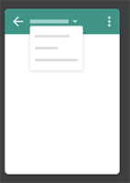

Please check more details from the Code and Video. I left note on where I made changes!